

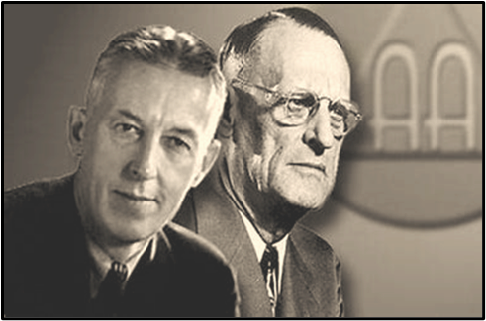
St. James Church Hall - 181 Portland St. Dartmouth, NS

NS Provincial Round Up ‘25 June 6 & 7

“FOUNDATIONS OF FREEDOM”

90TH ANNIVERSARY OF ALCOHOLICS ANONYMOUS



8:30PM-11PM
Main Room
Dance – 50’s Sock Hop OR Whatever Works for YOU!
Main Room
SOBRIETY COUNTDOWN!! Emcee: Reign
Special Thanks!
ALL OF YOU, THE ATTENDEES!

We need your feedback! Please complete this quick survey about your experience at the round up.


Have Questions/Need Help?
Role | Name | Phone
Committee Chair | Heather
Hospitality Chair/Archivist | Kathy
Hospitality Co Chair | Avelene
Registration Chair | Michael
Registration Co Chair | Sara
Program/Entertainment Chair | Marie
Program/Entertainment Co Chair | Cori

8:05PM-8:20PM
BANQUET SPEAKER-Joe G. Topic - “Foundations of Freedom”
Main Room
7PM-8PM
Saturday-June 07 cont’d cont’d


8AM-9AM

Guided Morning Meditation (Nathaniel B) OR 5K run / 3K walk (Allison M & Erin L)
start the day with a guided meditation

Secondary Room & Outside
Saturday-June 07
8:00AM

Foyer/Main Room
Registration Opens/Archives Display

Secondary Room
9:10AM-10AM
PANEL - Michael H., Mark L., Cori C. “Relationships in Recovery”

SPEAKER - Foster L.
Topic - “Foundations of Freedom”
Main Room
10:10AM-11AM
Main Room
Secondary Room
SPEAKER - John H.
Topic - “Foundations of Freedom”
PANEL - Mark Z., Barry L., Lisa L.
Sponsorship-How and Why?
5:15PM-6PM

6PM-7PM

DINNER BANQUET -Ticket Required
BREAK/SET UP FOR DINNER
Main Room
Main Room
Main Room

4PM-5:15PM

Secondary Room
PANEL - Val, Branden, Terri B. “Contempt Prior to Investigation-Does it just apply to spirituality?”
Secondary Room
PANEL -Samaira G, Mary W, Darren D
Chairing a Meeting- “Is it cross talk? or do I just need a snack?”

1:05PM-1:50PM
5:30PM
6:30PM
8-10PM
6:45PM-7:45
Welcome & Opening Remarks
Registration/Doors Open & Archives

LONGTIMER PANEL-Andy C. & Fred D.
“How do they keep their program fresh?”
Main Room
2PM-2:50PM
SPEAKER - Emma D.
Topic - “Foundations of Freedom”
Main Room
Foyer & Main Room
Main Room
Main Room
- Rock Paper Scissors Extreme
- Ice Cream Social
- Games Night

SPEAKER – Judy H.
Topic - “Foundations of Freedom”

Main Room
Saturday-June 07 cont’d

Friday-June 06
3PM-3:50PM
11:10AM-12PM
Noon-1PM

LUNCH-Ticket Required
SPEAKER - Dwayne MacD.
Topic - “General Service Conf. in NYC. What is it?”
PANEL - Jason C., Terri B., Isaac “Driven by a hundred forms of fear, self-delusion, self-seeking & self-pity”
SPEAKER - Matt F.
Topic - “Foundations of Freedom”
Secondary Room

Main Room
Secondary Room
Main Room

