 |  | District 9 Newsletter | April,2024  Issue #10
 |  | “CARRYING THE AA MESSAGE”
District 9 Group Committee 2023  DCM –Monty C.  ADCM –Peter M.  Treasurer - Susan R Secretary –Chelsea N. PI/CPC - Joe M Corrections – Joe M. Newsletter –Robert T  DISTRICT 9 TELEPHONE ANSWERING SERVICE  902-562-8019 |  | 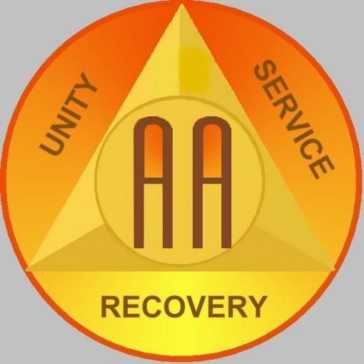
Editor’s Note:
*The next district 9 meeting will be in Sydney at the Friendship Hall (129 Charlotte Street) on Sunday April 21 at 2 Pm.
*Anyone looking to be on the Corrections committee, please contact Joe M. - (902) 317-3777 macjosa@gmail.com please
* We are also looking for volunteers to chair and be members of literature, Treatment, Bridging the Gap.

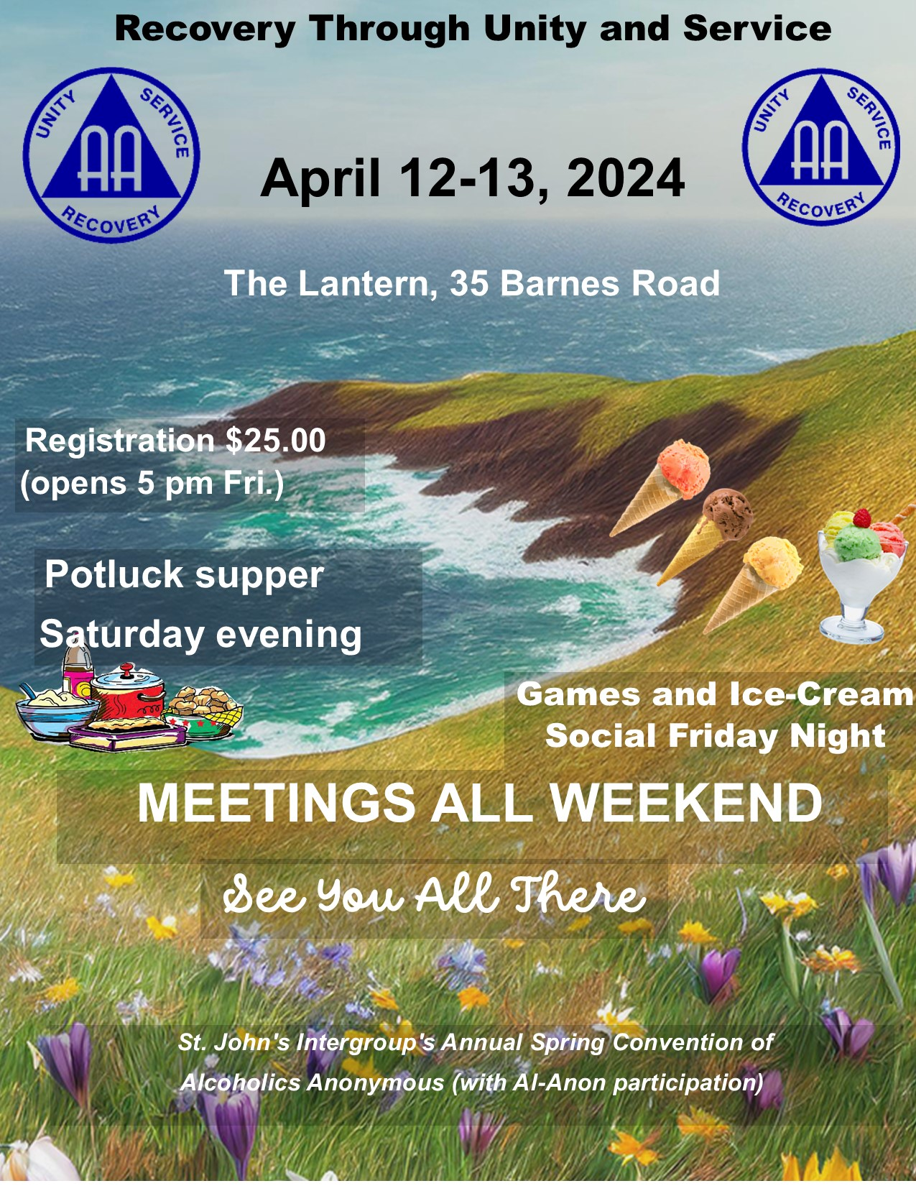
EARLY BIRD FLYER MAY DAY 2024
"There is a Solution"
COME SHARE WITH US BRIDGEWATER MAY DAY!
SATURDAY, MAY 18, 2024
Holy Trinity Anglican Parish Hall - Home of the Action Group
78 Alexandra AvenueBridgewater, Nova Scotia
REGISTRATION STARTS AT 9:00 AM
Meetings all day starting at 9:30 AM Guest Speaker 6:30 PM
A.A., Al-Anon & Friends - $15.00 Alateen- $7.50
Price Includes Registration, Lunch, Supper and Fellowship
Lunch and Supper provided (vegetarian option available)
Coffee, Tea & Donuts free all day
Pop & Water for sale
50/50 Draw
Bridgewater Archives Display all day
Contact Persons: Barb K-H 902-293-9803
Becky H 902-523-0040
Meet new friends for a great time and fellowship!
We look forward to seeing you there!

MEETING SCHEDULE:
C-Closed, O-Open, D-Discussion, S-Speaker

Group Time Type Notes/Addresses
SUNDAY | Alano Group | 11:00 AM | F2F-CD | End of month – Open Speaker  10 McKeen St. Glace Bay. (Rear)
 | Sydney Mines | 11:00 AM | F2F-CD | 55 King St, Sydney Mines
 | Sydney Central | 7:00 PM | F2F-CD | Friendship Hall, 139 Charlotte Street, Sydney.
 | Alano Group | 8:00 PM | F2F-CD | 10 McKeen St. Glace Bay. (Rear)
MONDAY | Arcano | 10:30 AM | F2F-CD | 401 Ling St. New Waterford
 | Reserve Midway | 8:00 PM | F2F-CD | Glace Bay Alano Club Rooms  10 McKeen St. Glace Bay. (Rear)
 | Back to basic | 8:30 PM | F2F | T.W. Curry community center (Corner of Prince & George)
TUESDAY | 12 & 12 Group | 11:00 AM | F2F-CD | 381 Whitney Ave, Ashby (St. Theresa’s Church)
 | Dominion group | 8:00 PM | F2F-OS | Italian Hall, 14 Gratto St
 | Iona 12 Step Group | 7:00 PM | F2F-CD | Iona Parish Hall 2516 St. Columba RD (Beside Iona Church)
 | Step Meeting | 7:00 PM | F2F-CD | Bring your Big Book  10 R McKeen St. Glace Bay. (Rear)
 | Ashby Group | 8:00 PM | F2F-CD | 381 Whitney Ave, Ashby (St. Theresa’s Church)
 | Lifeline Group | 7:00 PM | F2F-CD | 34 Archibald Ave, North Sydney (St. Josephs Church).
 | Louisburg Group | 8:00 PM | F2F-CD | 7532 Main St, Louisburg (United Church Hall)

WEDNESDAY | Alano | 11:00 AM | F2F-CD | 10 McKeen St. Glace Bay. (Rear)
 | Boisdale Serenity | 7:00 PM | F2F-CD | Firehall, 3810 Grand Narrows  Highway Route 223
 | Arcano | 8:00 PM | F2F-CD | 401 Ling St. New Waterford
 | Praying Hands | 8:00 PM | O-Speaker | 70 Gabriel St, Esksoni (Mi’kmaw Lodge)
THURSDAY | Friends of Bill | 11:00 AM | F2F-CD | 381 Whitney Ave, Ashby (St. Theresa’s Church)
 | Membertou | 7: 30 | F2F-CD | 3 Kateri St (Trailer), Membertou.
 | Sydney Mines | 8:00 PM | O-Speaker | 55 King St, Sydney Mines
 | Lean On Me | 8:00 PM | Zoom | ID 845 1060 2831 (pw 040328)
FRIDAY | Friday Fellowship Group | 11:00 AM | F2F-CD | 381 Whitney Ave, Ashby (St. Theresa’s Church)
 | Alano | 8:00 PM | F2F-CD | Open speaker last Sunday of the month. 10 McKeen St. Glace Bay (rear)
 | Westside Group | 8:00 PM | F2F-CD | 1840 Kings Rd, Sydney River  First Friday of the month Open Speaker.
SATURDAY | Big Book Study | 10:30 AM | F2F-CD | Bring your Big Book  10 McKeen St. Glace Bay. (Rear)
 | Way of Life | 11:00 AM | F2F-CD | 55 Inglis St, Sydney (Salvation Army Citadel) During Dec 2023 will be at T.W. Community Center.
 | Arcano | 8:00 PM | C-Speaker | End of month is Open Speaker. 401 Ling St, New Waterford.
Abbreviations used: F2F = Face to Face meetings. Zoom ID = Zoom meetings require an ID number to access the virtual meeting pw = password for zoom me

Al-Anon is a mutual support program for people whose lives have been affected by someone else’s drinking. By sharing common experiences and applying the Al-Anon principles, families and friends of alcoholics can bring positive changes to their individual situations, whether or not the alcoholic admits the existence of a drinking problem or seeks help.
Alateen, a part of the Al-Anon Family Groups, is a fellowship of young people (mostly teenagers) whose lives have been affected by someone else’s drinking whether they are in your life drinking or not. By attending Al-ateen, teenagers meet other teenagers with similar situations. Al-ateen is not a religious program and there are no fees or dues to belong to it.
Information is available online at:
https://www.al-anonmaritimes.ca/district9.htm
Or the local phone number in CBRM area is: 902-564-5188

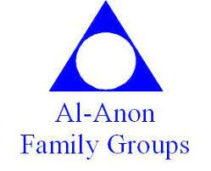

French Speaking Members here to help
Les AlcooliquesAnonymes

Les 12 étapes des AA sont les principes du rétablissement personnel. Les 12traditions garantissent l’unité du mouvement AA. Dans la municipalité régionale du Cap Breton, nous avons plus de 25 groupes AA qui se réunissent chaque semaine. Si vous êtes nouveau dans la région de Sydney et vous désirez de l’aide pour arrêter de boire. Je vous invite à communiquer avec Monty au 902-577-7348 afin d’obtenir de l’aide en français.
I am responsible when anyone anywhere reaches out for help, I want the hand of AA to be there and for that I am responsible!

THIS PAGE WILL BE UPDATED WHEN I RECEIVE NEW CONTACT INFORMATION DISTRICT 9 COMPLETE, WAITING ON AREA 82 UPDATES.
CONTACT INFORMATION
DISTRICT 9 (local):
DCM – Monty C. (902) 577 7348 monty056@hotmail.com
ADCM - Peter M. - (902) 562-0008 peter.marshe@yahoo.com
Treasurer - Susan R. - (902) 578-0371 susanroberts40@hotmail.com
Secretary –Chelsea N. (902) 304 7311 chesea.mae000@icloud.com
PI/CPC Chair - Joe M. - (902) 317-3777 macjosa@gmail.com
Corrections Chair – Joe M. - (902) 317-3777 macjosa@gmail.com
Newsletter Editor – Robert T. - (902) 578-8619 rbtargett@hotmail.com
AREA 82 Officers:
GSD (General Service Delegate) - Gerry W. - (709) 330-5799 gsd@area82aa.org
Area Chair – Anne B. - (902) 890-6274 chair@area82aa.org
Area Secretary/Registrar – Debbi C. - (902) 623-0828 secretary@area82aa.org
Area Treasurer - Jocelyn I. (709) 636-0208 treasurer@area82aa.org
Newfoundland & Labrador Archivist - alt_gsd@area82aa.org
Nova Scotia Archivist - ns_archivist@area82aa.org
Area 82 Webmaster - (902) 293-3117 webmaster@area82aa.org
District 9 (Industrial Cape Breton Area)
Telephone Answering Service (902) 562-8019

CALENDAR OF EVENTS
BIRTHDAYS / ANNIVERSARIES / RECOGNITIONS

DATE | GROUP(See group address on Meeting Schedule Above) | EVENT or MEMBER
April 24th | Boisdale 7PM | Courtney H

